Over 60 - (r)evolution of technology use among Bulgarian participants in project SAAM
Authors: Zlatka Gospodinova, Nadejda Miteva, Vera Veleva, Yordan Dimitrov, Kaloyan Haralampiev

Abstract: Project SAAM (Supporting Active Ageing through Multimodal coaching) aimed at providing new methods supporting Europe’s ageing population to remain active and live independently at home for as long as possible. This article presents the case study of designing the SAAM system for and and testing it together with seniors, sharing the experience from Bulgaria. The article particularly focuses on project results in the area of technology uptake among seniors. SAAM proved to be a system with significant potential to meet seniors’ active ageing needs, because of its high level of personalisation. On the other hand, most Bulgarian seniors participating in the project managed to adapt to having the SAAM system present in their lives regardless of their previous experience with technologies or lack thereof. Thus, SAAM contributed to answering some of the open questions in the field of active ageing. Still, observing the interplay between the complex and multi-domain system’s functioning and seniors’ experience with it inevitably raised new questions to be answered in the future;
Keywords: active ageing; seniors; coaching; smart technologies; SAAM

JEL: O30; O32; O35

- INTRODUCTION
Over almost four years, the project Supporting Active Ageing through Multimodal coaching (Project SAAM, grant agreement number 769661) attempted to create an unobtrusive system that could meet the needs of seniors in various domains of everyday life.
The following article presents the case study of designing and testing the SAAM system with the help of seniors in Bulgaria, with an intended focus on project results in the area of technology uptake. The article begins with describing SAAM’s background. It then continues with describing the user needs and requirements elicitation process and results. This chapter provides a practical testimony of how Bulgarian seniors perceive smart technologies. The following chapter elaborates on the setup and results from the SAAM pilot studies and demonstrates the evolution of seniors’ perceptions owing to their experience with testing the system. The article concludes with posing some challenging questions yet to be resolved in the active ageing research field. Due to its case study nature, notes on employed methodologies and literature are included in each chapters.

- BACKGROUND
SAAM is an ambitious project aiming at providing new methods supporting Europe’s ageing population to remain active and live independently at home for as long as possible. SAAM is implemented by a consortium comprising ten partners from five European countries. It is a research and development project, whose innovation is providing a multimodal virtual coach using novel technologies, which can be used by both tech-savvy and under-served, technologically inexperienced seniors.
To achieve its aim, SAAM uses technological innovations supporting independent life through ambient sensing and user modelling, including learning user performance and preferences, and providing personalised coaching either through the system or through its user’s social network.
In recent years, there have been numerous recommendation (coaching) systems supporting individual life domains of seniors, including health, activity, and others. SAAM and several other projects were launched under Horizon 2020 programme, all aiming at creating integrated systems covering several domains and using various advanced technologies (Andreoni et al., 2021).
What makes SAAM stand-out among these and other similar initiatives is that the SAAM system is highly unobtrusive and that it utilises senior users’ social circles in two ways – as part of one of the intervention domains “Social activity” and as a coaching modality. SAAM does this by introducing a friendly environment for social circles engagement in the SAAM models and application.
In SAAM’s concept active ageing is measured through quality of life understood as well-being or “…the balance point between an individual’s resource pool and the challenges faced…” (Dodge et al., 2012). SAAM system supports the seniors in maintaining themselves in personal homeostasis with respect to well-being by balancing between available individual resources and challenges (Dodge et al., 2012).
This balance requires a holistic approach where the overall aim of contributing to the physical, mental and social well-being is achieved by encouraging continued participation of seniors in the social, economic, cultural, spiritual and civil life with the support of senior’s relatives, friends, neighbours and the community (the “social circles”).
As a long-term and complex project, SAAM has several stages, beginning with user needs and requirements survey and continuing with six stages of modelling and technical development, and ending with a pilot study with end users. Both the initial survey and pilot studies were conducted with a mixed-method approach seeking feedback from seniors, stakeholders and communities.
Intervention domains elicited from the initial survey and tested during the pilot studies are mobility, activity, sleep and social activity. The technical part of the work included hardware integration (sensors, communication devices and wearables) and software development (algorithms, database and application).
The SAAM logic begins with data collection through sensors, continues with data processing with algorithms running within domain pipelines and ends with rendering personalised recommendations, using the output from pipelines combined with user preferences.
User-centred design is part of the project foundation. Apart from direct user feedback elicited during the initial survey, user needs and requirements are entwined in the work done throughout the virtual coach development process. This process includes creating user profiles and corresponding pipelines, the latter encompassing data collection, data processing and coaching rendering.
As part of SAAM, an innovative research is performed in the advanced cognition and emotion domain. Speech and audio processing is used to inform interventions for healthy ageing by analysing acoustic data captured in the user’s home. A major challenge of handling such data is to ensure privacy and data protection. As part of the project, a low-cost system is used to extract audio features, which do not preserve the actual spoken content. These privacy preserving features have a potential in emotion recognition (Haider and Luz, 2019), cognition status prediction (Haider, Fuente and Luz, 2020) and eating conditions (Haider et al., 2018). The features are tested in algorithms developed as part of the SAAM project in the area of health and well-being monitoring.

- USER NEEDS AND REQUIREMENTS ELICITATION
  - Initial end-user engagement approach and target group
By definition, needs assessments aim at establishing the gap between "what it is" and "what it should be". Since the goal of SAAM project is to provide new methods in supporting the ageing population to remain active and live independently for as long as possible, the gap is investigated mainly with regard to guidance and care seniors need in order to age actively. To be able to carry out this investigation, a user needs and requirement survey is carried out using a mixed-method approach including desk research, a quantitative survey and a qualitative inquiry (including an interview, a home tour and an observation).
The target groups of the needs assessment were seniors, caregivers, close social circle (family, friends, and neighbours), key experts and the wider community. With view to the planned interventions, the seniors were referred to as primary users (PUs), the seniors’ caregivers and close social circle are referred to as secondary users (SUs) and the rest are referred to as tertiary stakeholders (community, key experts, etc.).
The main target group of the project as a whole and the needs assessment in particular are seniors above 60 years of age, including such from most underserved segments in economically underdeveloped regions and with very low technical proficiency. The survey used a convenient sample of end users from cohorts of their service organisations – the Bulgarian Red Cross (BRC) and Caritas Bulgaria. Participants in the survey were 188 in total: 116 from the Bulgarian Red Cross and 72 from Caritas social partner organisations, of whom 16% were male and 84% were female. The participants were from four age groups – 40-65 years of age (19.9%), 66-70 years of age (24.7%), 71-80 years of age (41.4%) and 85 and over years of age (14%).

  - User needs and requirements survey
SAAM is a novel technology and one of the important objectives of the survey was to take a snapshot of the baseline concerning seniors’ use of technologies. Prevalence of technology use by target group is shown in Fig. 1 below.

Fig. 1 Baseline use of technology
Source: Own data

Not surprisingly, all seniors have and use a TV, most use landline or mobile phone and a radio. A somewhat surprising result is that 78% use some kind of health monitor, predominantly a blood pressure monitor.
Even though the surveyed seniors are in an age group that does not feel very comfortable with using new technologies, some 9% of the respondents use a smartphone and 35% use Internet. These are mostly seniors from the more active Bulgarian Red Cross cohort, as illustrated by Fig. 2 below, where 46% use Internet and around 30% use social networks and (video) chat platforms and email.

Fig. 2 Use of technology comparison of BRC and Caritas cohorts
Source: Own data

A more subjective perspective on attitude to technologies was surveyed by asking several questions related to how comfortable seniors feel with using technologies. Users showed the highest rate of agreement (above 30%) in their responses to the statements “I enjoy learning new technologies and hearing about new technologies”, “People expect me to know about technology and I don’t want to let them down” and “Technology is my friend” (Fig. 3). The highest rates of disagreement were expressed to the statements “I know how to deal with technological malfunctions or problems” (more than 70%), “Solving a technical problem seems like fun challenge” and “I find technology easy to learn” (more than 60% for both). The combination of these responses may give grounds to conclude that seniors do not have an irrational fear towards technologies, but rather lack the skills in using and learning about the new technologies.

Fig. 3 Subjective experience of end users with technology
Source: Own data

  - Interviews and focus groups results
The second step of the user needs and requirements assessment at the beginning of the SAAM project consisted of conducting in-depth interviews with seniors in Bulgaria. These interviews were part of the process of eliciting users’ needs, focusing mainly on capturing seniors’ verbalised needs and their perception of the living environment. In parallel to the interviews with seniors, SAAM researchers conducted focus groups with several target groups, namely seniors caregivers (formal and informal), persons from seniors’ social circle (i.e. family members, friends, neighbours), as well as people in their 50s (nicknamed in the project “near-future seniors”). The interviewed seniors and the participants in the focus groups were mostly not related with each other. A third format used for eliciting seniors’ needs were key-informant interviews offering a higher-level perspective of systemic challenges faced by seniors in their lives. All types of qualitative interactions were audio recorded with the explicit consent of the participants. A total of 8 in-depth interviews with seniors, 3 key informant interviews and 5 focus group transcripts were analysed.
The interviews and focus groups transcripts are analysed using formal and informal content analysis. Informal content analysis at the sentence level revealed a tendency for seniors to use technology to the extent to which they need it (i.e. they are not curious beyond their immediate needs). This observation can be illustrated with the following quotes: “we have one computer, but I use it as a typewriter”. On the other hand, the general perception of seniors towards smart technology varies depending on their perceptions of new, unfamiliar concepts and objects in general: “I know elementary things, but I can’t say I use it freely. I’m a little scared of this technology, because we didn’t have it back in the days” compared with “I’ve had [the smartphone] for quite a while now and I feel nice I have it”.
The formalised content analysis of the interview and focus-group transcript corpus is done with the aid of the Java-based ModNLP corpus analysis software (Genealogies of Knowledge 2018). It is also performed at the sentence level with a focus on concordances (Luz and Sheehan 2020). The concordances reveal information regarding seniors’ activities and daily rituals and their needs for close social contacts.

Fig. 4 Mosaic diagram of word “контакт*” (contact / be in touch) in intervews with seniors subcorpus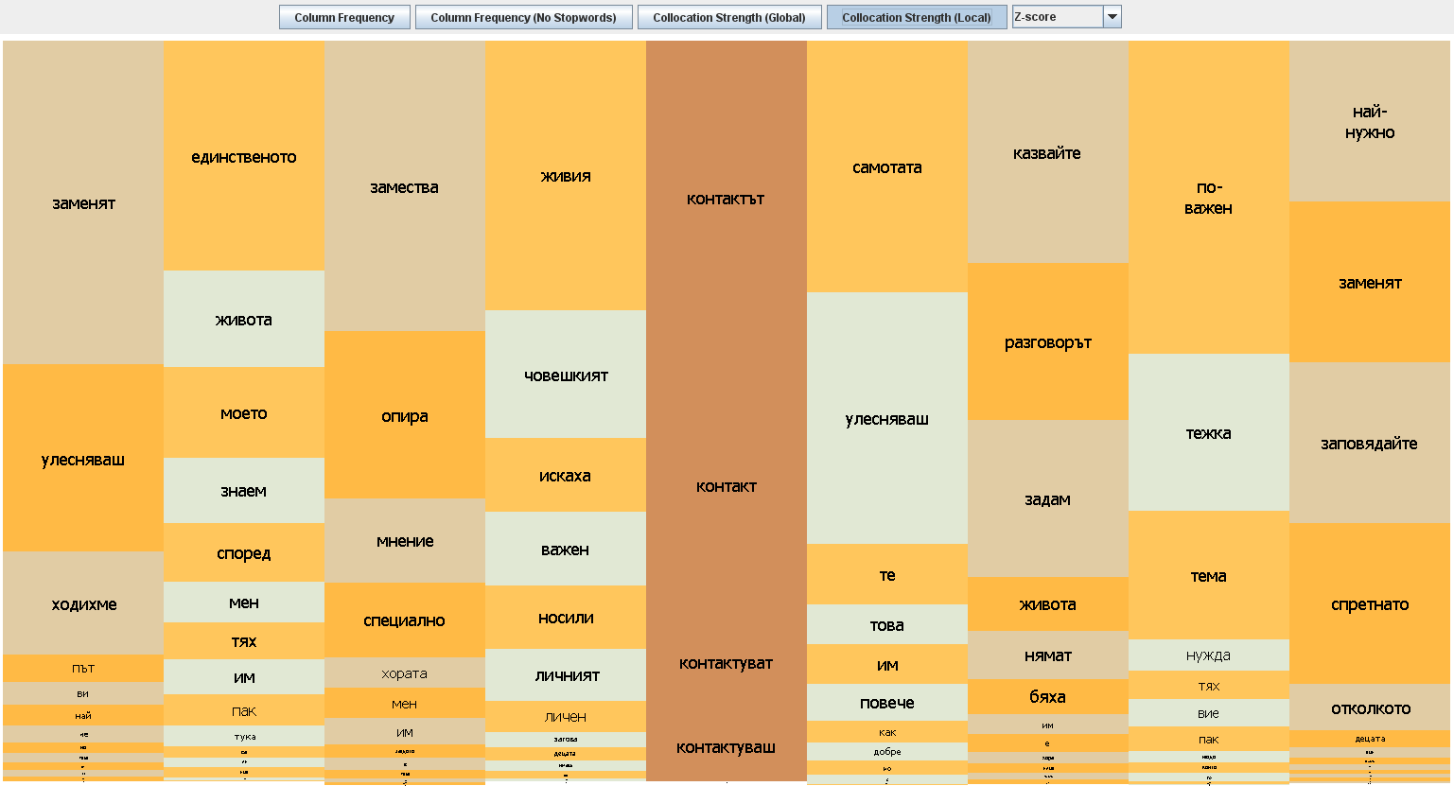
Source: Own data

Fig. 5 Mosaic diagram of word “говор*” (speak / talk) in interviews with seniors subcorpus
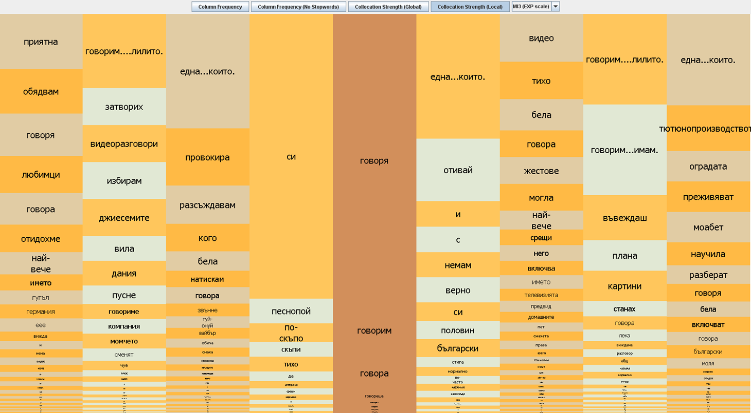

Being in touch with others is perceived as a vital need by seniors (Fig. 4). Speaking, talking (i.e. using their voice) is an important activity in the everyday lives of interviewees (all participants have used the verb) (Fig. 5). Talking is the way interviewees prefer to communicate with the people in their social circles. Seniors mostly communicate with their closest relatives (“son”, “daughter-in-law”, and “granddaughter”) and their friends. The verb “speak” / “talk” is used in conjunction with new technologies, such as Skype, Viber, Google. Interestingly, those seniors who have friends or relatives abroad are keen on using videochat functions of these apps. Notably, however, focus group participants do not perceive new technologies for remote communication as a possible substitute for “live / personal / human relations” in seniors’ lives.

  - The user-system link as defined by the needs assessment
The interactions with target group representatives who were also potential SAAM users substantiated the understanding of the SAAM consortium of what seniors’ needs and requirements towards the SAAM system were. The results from these interactions defined the user-system link in a step-wise sequence visualised in Fig. 6.

Fig. 6 User-system link
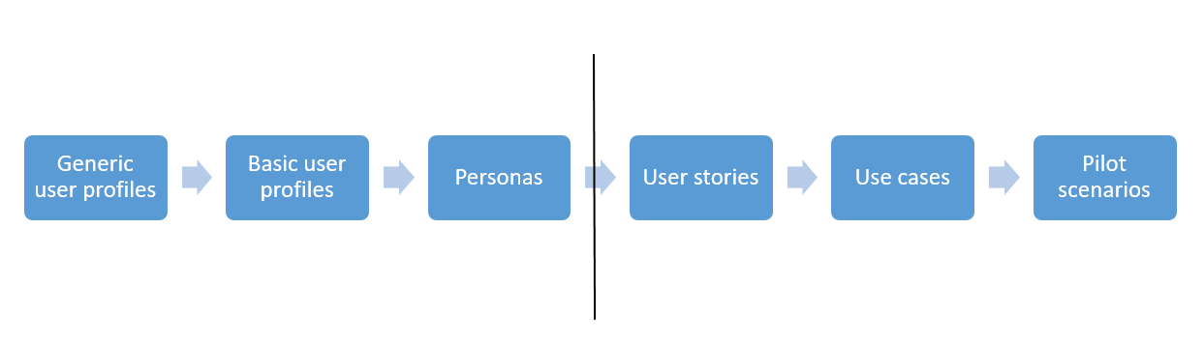
Source: Own data

Generic user profiles (and consequently basic user profiles) are created on the basis of seniors’ responses in the quantitative survey in the beginning of the project. These are, then, enriched with qualitative information gathered through the contextual inquiry (in-depth interviews, home tours and observations) to create personas (Blomkvist 2006). These three steps are directly informed by the data gathered through fieldwork and are decisive for the high-level design of the SAAM system. At a later stage, the personas are operationalised into user stories, use cases, and pilot scenarios, respectively. Those three steps define the details in the system’s design and validation process. Below, we discuss the results from the first three steps, namely generic user profile, basic user profile, and persona definition.

  - Defining user profiles
The approach used to elicit generic, and later basic, user profiles from the survey data was to apply cluster analysis (Tan et al, 2019) in a two-step process. The first round of the cluster analysis was carried out employing in parallel Multidimensional Scaling (Science Direct 2021) using the statistical software Orange (Demsar et al, 2013) and filtered clustering (Kumar and Ramma Mohan Reddy, 2017) using R and Weka softwares (R Core Team, 2021; Frank et al, 2016). The results obtained through the parallel calculations are similar (see below Fig. 7 and Fig. 8).

Fig. 7 Multidimensional Scaling results
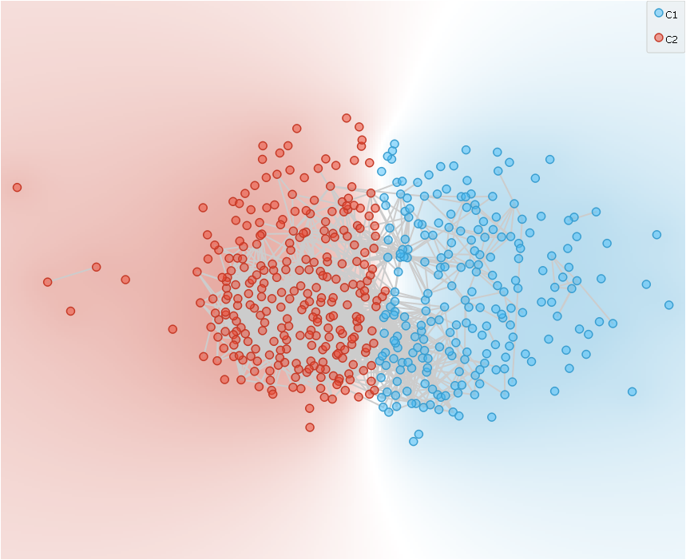
Source: Own data

Fig. 8 Filtered k-means clustering results
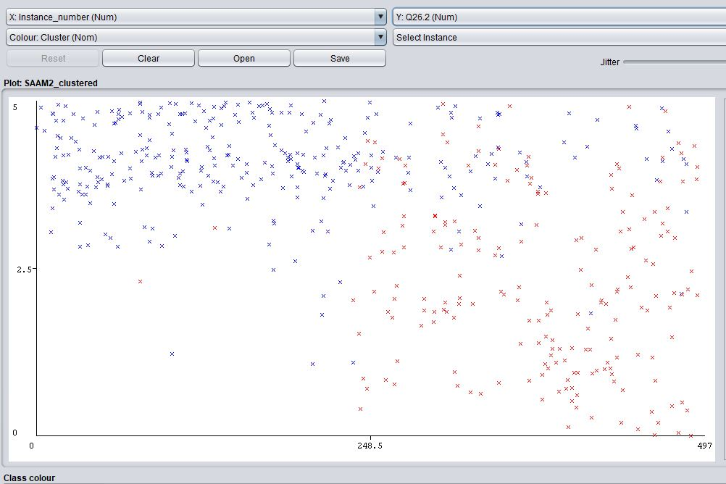
Source: Own data

The purpose of using these methods was to find whether there was an inherent division between subjects within the sample by taking into account all variables “as they were”. The surveyed sample of seniors formed two main clusters. The division into the two clusters turned out to be strongly related to seniors’ attitude toward technology in general. The attitude towards technologies was so strong that it obscured the other differences (groupings) within the sample. This is why in the second step of the analysis the results from the technology related survey questions were disregarded and Hierarchical Cluster Analysis was employed instead (Tan et al, 2019), again using the Orange software. Applying this method allowed to reveal the second strongest variable (set of variables) determining the division in seniors’ characteristics. This second strongest variable proved to be pertinence to one of the organisations, from whose cohorts seniors were recruited to participate in the needs assessment.

Fig. 9 Hierarchical Clustering results
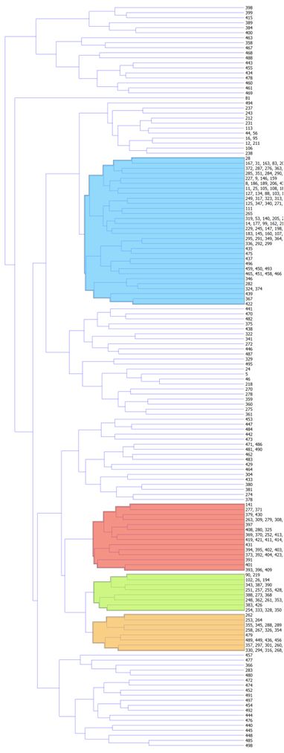
Source: Own data

The results from the Hierarchical Clustering allowed the team to define four main generic user profile (one for each of the participating end-user organisations in the project, namely Bulgarian Red Cross, Caritas, EURAG, and SOČA).
After completing the generic user profiles, it was important to dive even further into the characteristics of senior participants in the survey. Since the survey data contained both categorical and continuous variables, a TwoStep Cluster Analysis using SPSS software (IBM Corporation, 2016) was employed. A total of 10 basic user profiles were revealed with this method, with groupings forming around demographic variables (age, area of residence, level of education) together with health and social life-related data. Two clusters were formed for each of the Bulgarian organisations (Bulgarian Red Cross and Caritas). In the cases of both organisations, one of the clusters appeared to be larger than the other.
The final step of creating a life-like image of seniors to feed into the design of the SAAM system was to substantiate the results obtained from analysing the survey data with the qualitative information gathered via interviews. The qualitative inquiry was organised after the quantitative analysis and senior interviewees were recruited in accordance with the clusters characteristics and density.
The mixed-method approach above allowed to create the SAAM personas over several dimensions: demographics and bio, skill level in several technologies (mobile phone, tablet, computer, wearables, and the Internet, key motivations and key behaviours with regard to technology, as well as goals with respect to technology use (Fig. 7)).

Figure 10 Personas' key motivation and behaviours with regard to technology use
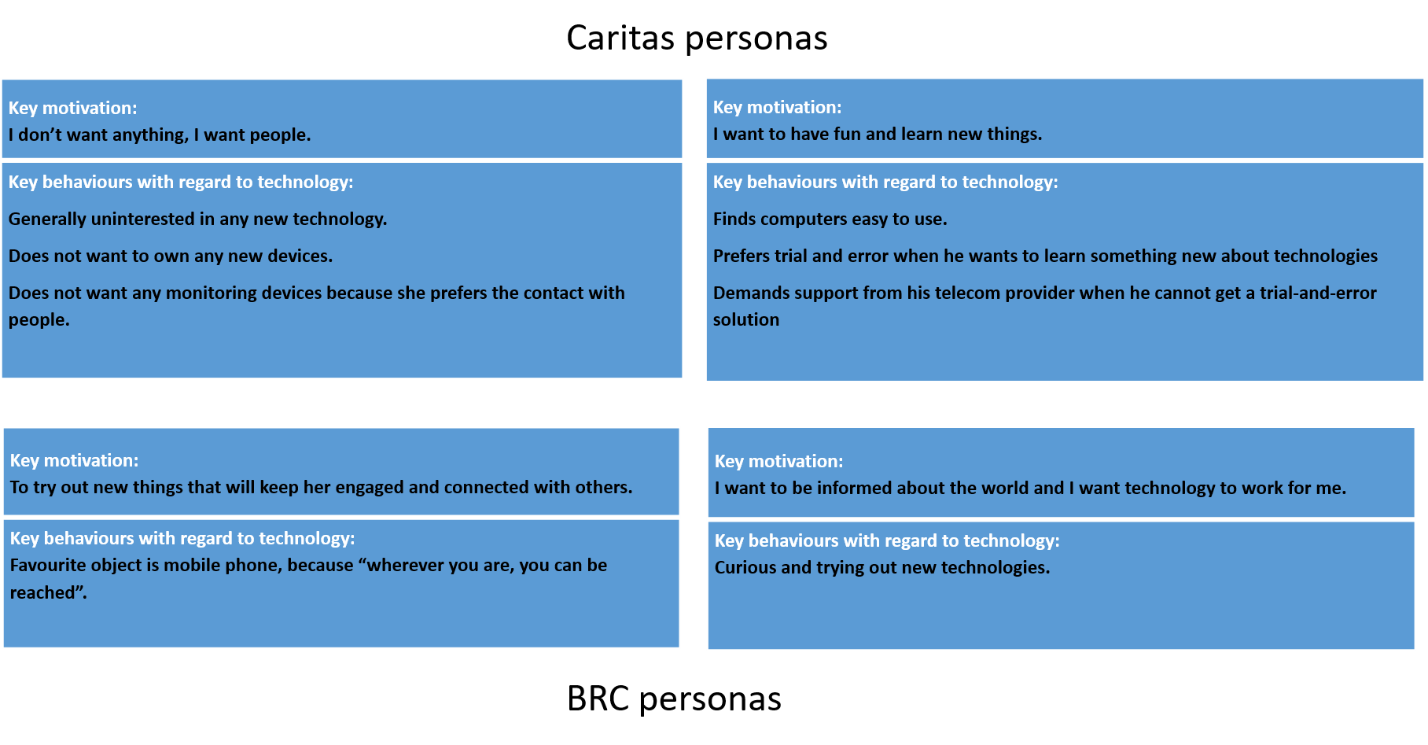
Source: Own data

Each basic user profile has its own corresponding persona that includes those needs to which the SAAM system could cater in a way preferred by the user. Each persona is also accompanied by user requirements towards the SAAM system.

  - User types and relations in the SAAM system
A significant conclusion from the interactions with potential users described above is that in order for a system like SAAM to be accepted by its senior users, seniors need to be able to interact with the system according to their perceptions of and aptitude with technologies. For some potential users this also means to not interact directly with SAAM at all. This is why within the SAAM system we created two types of users (primary user (PU), i.e. a senior user, and secondary user (SU) who can be of help to the primary user). The relationships between the two types of users determine the options, including rights that each user has in the system (Fig. 11). Understanding the relations between user types is important in view of interpreting the results from the pilot studies, as presented in the chapters below.

Fig. 11 SAAM user types and user roles
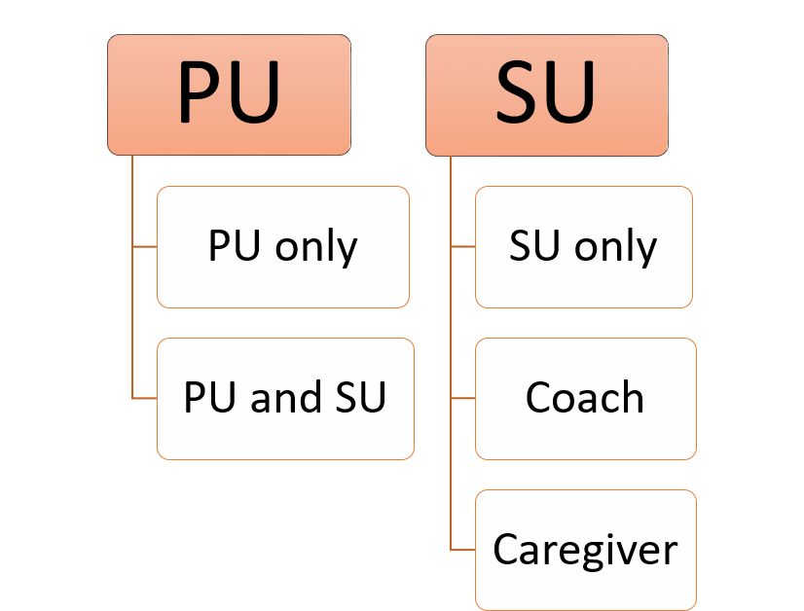
Source: Own data

Primary users can use the SAAM system on their own, but they can also act as a secondary user for other SAAM senior users. This situation can, for example, emerge if two senior friends want to use SAAM, one of whom is not as apt with technologies as the other. In such a case, the more experienced user can perform tasks on behalf of the less experienced user in the latter’s profile provided they are granted with respective permissions beforehand.
When it comes to secondary users, these could be senior users as in the example above or they could be any other person who wishes to be part of the SAAM community. Once a secondary user is connected with a primary user, they can interact as if they are in a social network (have voice calls, video calls and chats). If a primary user decides that they trust another SAAM user (be it primary or secondary), they can appoint them to be: (1) their coach, (2) their caregiver; or (3) both. When a user is a coach, they can receive coaching messages on behalf of the primary user who appointed them in this role. When a user is a caregiver, they can view or change items in the primary users’ profile (i.e. to manage the SAAM system on behalf of the primary user).

- PILOT STUDIES
  - Pilot studies end-user engagement report
The overall goal of the final stage - pilot studies - is to test and evaluate the developed virtual coach in real life. It also aims to assess whether SAAM has a positive impact on preservation of physical, cognitive, mental, and social well-being of ageing citizens. True to its devotion to the user-centred design, the pilot study is devised with the specific objectives to investigate and verify the persuasive effect of the system and its long-term usability and efficacy, as well as to ensure a high degree of usability, acceptance and positive user experiences with real users of varying ages, abilities and needs, and with stakeholders and communities.
The pilot study involved several different user interactions – long-term pilot study with senior end users of SAAM, single sessions and stakeholder feedback gathering activities, defined below:
- Long-term pilots are long-term SAAM installations at primary users’ homes for three months with the possibility to have them extended for up to six months for a limited number of primary users depending on their willingness to participate.
- Single sessions are defined as one pilot participant trying out SAAM. Pilot participants are continuously surveyed about their acceptance of the technology and their opinions on usability and user experience.
- Stakeholder feedback gathering activities are focus group discussions and key-informant interviews with caregivers, families, and personal networks members (friends, neighbours), eliciting the opinions and attitudes towards the SAAM system.
The long-term pilot study participants were invited from among the end users who participated in the initial needs assessment survey – seniors from cohorts of the Bulgarian Red Cross and Caritas Bulgaria. The overall sample of the long-term pilots consisted of 28 participants, whose mean age was 72 years.
The pilot testing was performed on a strictly voluntary basis, where users could choose to test the SAAM system either for 3 or for 6 months. The test period, however, was changed due to the fact that coaching modules were finished and deployed at different times (social activity coaching, for example, started providing coaching in early 2021). Given this situation, additional volunteers were recruited in Bulgaria in the last quarter of the active piloting of the SAAM system, some of whom managed to test the SAAM system in its most stable and mature version, but within a shorter testing period of two months.
The most complete SAAM installation package for the long-term pilot studies included a Wireless Local Area Network (WLAN) router, an Internet router, an ambient device (composed of a Raspberry Pie (rPi) and a MatrixCreator), an edge gateway device (eGW), ultra-wideband sensor(s) (UWBs), a sleep sensor, a belt clip sensor, a bracelet sensor, a smartphone and a tablet. The devices differed for the different participants depending mostly on the domains they had selected for pilot testing and partly on the users’ desires.
The pilot study objectives were achieved in the long-term pilots by studying the effect of the SAAM system from two perspectives: Technology Acceptance and User Experience, and Coaching and Wellbeing. The latter perspective was studied through its domains - mobility, activity, social activity and sleep.
Data collection had three main stages - pre-test, interim, and post-test. The data collection instruments used in the long-term pilots were semi-structured (in-depth) interviews, detailed user scoreboards (questionnaire measuring technology acceptance and user experience), diaries, field tests (mobility test), standardised scales (domain-specific quantitative data collection) and remote automatic data collection (SAAM data from sensors and application). There were deviations from some of the planned instruments caused by Covid-19 restrictions and technical development and deployment issues.
In addition to long-term pilot testing, single sessions were carried out with potential primary and secondary users, to study user acceptance of technology and opinions on usability and user experience. The third type of interactions – stakeholder feedback gathering activities (with caregivers, families, friends, neighbours, and experts in the field) – were used to study opinions, attitudes and public acceptance of SAAM. These activities comprised key-informant interviews, community interviews and focus group discussions. They were carried out following a demonstration of SAAM system and application using various video conference applications.

  - Results – Technology Acceptance and User Experience perspective
One of the perspectives explored during the SAAM pilot studies was how users accept the SAAM technology that was offered to them to test and what was their user experience with it. For that, SAAM researchers used a mixed-method approach combining a quantitative questionnaire (adapted from Steinke et al, 2014) and an interview template. In this section, we briefly discuss the results from the former, while in the next section we elaborate on the evidence from the latter. The quantitative results need to be read with caution, because of the small pilot study sample and the consequent lack of statistical significance of most results.
Overall, the Bulgarian participants in the pilot studies showed moderate satisfaction with the system. Looking at the pre-post results from the piloting, some technology acceptance and user experience dimensions marked an increase at post-measurement, while other showed some decline. In terms of users’ perceptions with respect to part of the different SAAM devices and the system overall (hardwarewise), participants opinions were positive.
On average, interest in technological devices among the Bulgarian participants was measured to be higher at the beginning of their testing period compared to the end (not statistically significant). Participants’ trust in the SAAM system increased (statistically significant). Participants’ willingness to use the system slightly decreased over the time of the pilot study (not statistically significant), while their assessment of the system’s usability improved (not statistically significant). Seniors’ perception of SAAM’s intrusiveness was very low from the beginning of the piloting and even slightly decreased over time (not statistically significant). Their perceived level of privacy slightly decreased throughout the piloting, but was quite high overall (not statistically significant), while their perceived level of data security increased during the piloting (not statistically significant).
The knowledge gained from the pilot studies was vastly enriched by the senior pilot users’ personal reports. These were collected by SAAM researchers on several topics, including on the users’ technology acceptance and user experience opinions.
The SAAM technology was most strongly perceived by pilot users in their interaction with the smartphones and / or tablets that they were provided for the duration of the piloting. Those users who were skilled in using smartphones, were rarely challenged to interact with the SAAM system via its dedicated smartphone application. Those users with moderate to no experience with smart technologies perceived the presence of the smartphone and tablet to be related to them being more in touch with the world around them (i.e. have more social contacts or be better informed about the world). One of the SAAM users reported that their habits changed “in expanding of technical capacity thanks to the devices”. Another user reported improvement in quality of life – “Yes, I do something new and this activates me”. Yet another user said that "They [a user’s social relations] improved because I had the means to communicate".

  - Results – Coaching and Wellbeing perspective
The goal of studying the Coaching and Wellbeing perspective is to evaluate the SAAM system in natural environments (the participants’ homes) and its impact on users’ quality of life, if any. In particular, it seeks to answer the following research questions:
- Whether the SAAM system is able to support seniors in maintaining and improving their individual objective wellbeing and
- Whether SAAM affects seniors’ individual subjective wellbeing.
The analysis is based on the information gathered with research instruments selected particularly to assess the seniors’ quality of life and provides an upper-level point of view on SAAM’s presence in the lives of pilot participants. The instruments used are a semi-structured interview and a paper-based quantitative questionnaire – the Older People’s Quality of Life questionnaire – 35-item (OPQOL-35) (International Longevity Centre UK 2019).
Fig. 12 below clearly shows that most senior participants in the long-term pilot study experienced a change in their quality of life between the pre-study and the post-study measurement. A number of participants report negative changes in their independence, control over life, and freedom. This may be expected because, at least in Bulgaria, the time between pre- and post-study measurements passed under the sign of the two largest COVID-19 waves to-date.
Interestingly, however, a number of participants reported positive developments in the three areas of their lives, with the most notable example being a considerable increase in social relationships / leisure and social activities.

Fig. 12 Changes in quality of life

Source: Own data

The coaching effect of the system was also analysed at the domain level. As an illustration, below we present part of the results in the social activity domain. This domain is selected, because during the initial survey Bulgarian seniors reported social contacts to be the most important domain in their daily lives and social isolation to be their main challenge with regard to their wellbeing, respectively. Data presented in Fig. 13 measures the changes in seniors’ social networks during the piloting period, depicting an aggregated social network and specific social networks - Friends and Family.

Fig. 13 Changes in social networks of seniors

Source: Own data

According to these results, in both Friends and in the aggregated results, more than half of the participants experienced positive changes in their social networks. In the Family group, 46% of participants experienced such a positive change as well. It is important to note that six of the participants whose answers are included in the sample left the pilot study shortly after the social activity pipeline was deployed on production environment and did not receive SAAM coaching in this domain.
Some 42% of the participants testing the social activity domain also reported having achieved their social goals during the pilot studies. The results, even though by approximation, show an impact of SAAM on seniors’ social life. In that sense, it is valid to claim SAAM positively contributes to the social activity of some users.
After having viewed part of the self-reported quantitative results in the social activity domain, the results from the qualitative survey are illustrated in Fig. 14 representing pre-study and post-study results per topic.

Fig. 14 Social life changes - topics

Source: Own data

Some 42% of the pilot participants declared to have achieved their goals in social life within the pilot study, whereas the answers of another 46% of participants indicated that there was no change with respect to their social life or that they had no particular goals to achieve. The remaining 12% reported they did not achieve the goals they had set for themselves in the social domain.
Out of all users, 28% reported positive and 24% - negative changes in their social relationships. The other half of the participants did not report any change in their social relationships. In the third group of questions, 80% of users reported no changes in the reasons why they communicate with their social contacts or the level of confidence they hold with their social circles.
Results from piloting may have been different had the COVID-19 pandemic not happened. However, it did and the pilot participants and research team could do little to alleviate the situation.
Even so, the results from the measurements in the social activity domain raise some interesting questions that need to be further explored, potentially in a study with a control group – contrary to general expectations a large number of users did not report a change in their social lives.
A third viewpoint from which SAAM’s effect was explored in the pilot study was that of the coaching rendered to end users. For the purposes of this article, we again illustrate it with results in the social activity domain (Table 1).

Tab. 1 User response to coaching for Social Activity
SOCIAL GENERAL
Coaching target user | Coaching completion status | No action followed by no action | No action followed by coaching | Coaching followed by no action | Coaching followed by different coaching | Coaching followed by the same coaching
PU | Cannot | 0.0% | 0.0% | 0.0% | 5.9% | 94.1%
PU | Declined | 0.0% | 0.0% | 0.0% | 0.0% | 100.0%
PU | Done | 0.0% | 0.0% | 0.0% | 15.6% | 84.4%
PU | (blank) | 0.0% | 0.0% | 0.0% | 7.2% | 92.8%
SU | Cannot | 0.0% | 0.0% | 0.0% | 0.0% | 100.0%
SU | Done | 0.0% | 0.0% | 0.0% | 9.3% | 90.7%
SU | (blank) | 0.0% | 0.0% | 0.0% | 8.5% | 91.5%
Grand Total |  | 0.0% | 0.0% | 0.0% | 8.3% | 91.7%
Total count | 733 |  |  |  | 61 | 672
Source: Own data

The results in the table provide a comprehensive overview of all coaching actions the SAAM system issued for all pilot users throughout their active piloting in the domain. Since SAAM provides explicit coaching only in situations in which it considers its user needs to get back to their homeostasis, we hypothesised that in situations in which coaching actions were followed by a period of silence of the system, the user had followed up on the system’s coaching and managed to return to their usual state of balance. This hypothesis was not confirmed because data about such situations was not gathered.
On the other hand, coaching actions that were followed by different coaching actions were a stable proportion of cases in the three specific social activity subdomains, namely “friends”, “family”, and “community”. In contrast, in the social general subdomain, these accounted for 8.3% of the cases, meaning the system was able to detect changes in situation relatively better in the general domain than in the specific ones.
In most cases, a coaching action was followed by the same coaching action, which could mean that the system, on one hand, regularly detected a need to intervene (users’ goals were consistently not met) or, on the other, the system was unable to detect completion of coaching actions. Both explanations are possible, even though the second one is more probable.
There are several confounding factors that reflect on the social activity detection. Even though the research team encouraged the users to use the dedicated SAAM phone regularly to make phone calls and users were instructed to carry the smartphone with themselves when they went out of their homes, the data on number of phone calls detected by SAAM is very low and is highly improbable that it reflects the real number of phone calls users had. Moreover, a number of users shared that sometimes they forgot to carry the dedicated SAAM smartphone when they went outside. A third confounding factor is that the SAAM application was, for an extended period of time, not able to continue working in the background of the Android operating system, which meant that whenever participants closed the open applications or restarted their smartphones, the SAAM app would close and would not collect social activity data as it was supposed to.

  - Results – SAAM’s case studies or the (r)evolution in technology use among seniors
As it was explained above, technology inclination and everyday use is specific to different seniors and depends on their overall take on life. Analysing the results from the SAAM long-term pilot study, this was confirmed once more as two main groups were shaped among the test users with respect to their technology use. One real-life (anonymous) case study per group is presented below.
An evolution user (let’s call him Vladimir) participated in the pilot study with some background experience with technologies and owning a mobile phone and a TV. He, however, had never worked with smart technologies prior to his involvement in the project.
As a result of his participation, he reported becoming more physically active because of wearing the SAAM bracelet. He also became more social as a result of the increased physical activity around town, as well as more connected to his core family. He learned how to charge his SAAM devices, but did not get used to actively using the smartphone.
A revolution user (let’s call her Vania) participated in the pilot study without any background experience with technologies, except for owning a mobile phone and a TV.
As a result of her participation, she reported becoming more connected to her core family abroad. She learned how to charge her SAAM devices and actively used the tablet to read news online, to search for recipes and listen to music on YouTube and to have video chats in Viber. Most surprisingly, she currently has installed Internet at home.

  - Stakeholder feedback and the future of SAAM
Stakeholder feedback gathering activities aimed at eliciting information, attitudes and perceptions towards SAAM of society as a whole, in order to anticipate the future consequences and challenges regarding the practical implementation of the SAAM system. They also aimed at acquiring a systemic view of the environment in which SAAM is to be operating.
Stakeholders in these activities were addressed individually (key informant interviews) and in groups (focus groups and community interviews) in order to validate SAAM’s coaching approach, software and hardware with varied groups, as well as to assess whether the SAAM concept and system are future-proof. Another aim was to obtain qualitative information from secondary users who piloted the system long-term on how SAAM was perceived by pilot participants (primary and secondary users) throughout the long-term piloting phase in Bulgaria. The qualitative approach used for these activities has a great value in providing in-depth understanding of attitudes, perceptions, and motivations of participants.
Stakeholder feedback gathering activities were carried out in Bulgaria with 70 participants and ran in parallel with the single sessions and the long-term pilots. Participants were three types – experts in relevant fields; potential future SAAM users – future seniors, caregivers and family members of seniors not included in the long-term pilots; public bodies’ decision makers, professionals in the field of healthcare and social support. Key-informant interviews were scheduled to last up to 60 minutes and community interviews and focus groups – up to 90 minutes.
Three types of focus groups were designed, targeting the following participants:
- Focus group 1: Potential primary users - persons over 60 years of age and “near future seniors” – persons between 50 and 60 years of age.
- Focus group 2: Experts in the field of adult care – social workers, volunteers, general practitioners, researchers, responsible persons from the local administration, etc.
- Focus group 3: Potential secondary users – social circle (relatives / family of elderly people, including elderly people, who participated in the long-term pilot study of the SAAM system, friends, neighbours), caregivers, including volunteers and general practitioners.
Targeted participants in community interviews were local communities of seniors, potential or actual primary and secondary users, social circle (relatives / family of elderly people, friends, and neighbours), caregivers, including volunteers.
Targeted participants for key-informant interviews included policymakers in the areas of health, information and communication technologies, and social services; representatives of municipal and regional authorities in the areas of health, information and communication technologies, and social services; representatives of consumer organisations; representatives of patient organisations; representatives of the (middle and higher) management tier of charitable organisations such as Caritas, Bulgarian Red Cross, and others; representatives of businesses in the area of electrification or telecommunications; experts in innovations; non-professional users of technologies serving a purpose similar to SAAM.
The analysis procedure followed a three-step deductive-inductive approach.
First, audio material from the discussions was transcribed, trimmed for relevant texts and structured around categories, which were defined beforehand (deductive approach). These categories are based on: the general perspectives (e.g., technology acceptance, UX, coaching, wellbeing) and the domains (e.g., sleep, social, activity, mobility).
Next, new categories that emerged in the process of analysing the data (inductive approach), are also integrated into the analysis. These are seniors’ characteristics; seniors and technologies; systemic issues (related to seniors); privacy; SAAM’s future; SAAM’s use (exploitation).
Finally, the above categories were interpreted and quoted in a narrative with respect to the key information. The times spent on different SFGA was: Key-informant interviews - 538 min. (782 min.); Community interviews – 111 min. (131 min.); Focus groups – 210 min (total 453 min), respectively.

The SAAM concept was broadly accepted and approved by the participants. The major challenges to be addressed with regard to any system supporting seniors’ active ageing were the inability of Bulgarian seniors to use technologies and the fact that no system could replace human contact. Nevertheless, according to secondary users’ reports on their primary users’ positive experiences with SAAM:
“... the person was waking at night, they were looking at the clock and there was light. So, they accepted it as a “buddy”, a “presence”. I observed such situations related to the approval and acceptance of SAAM by some of the PUs. SAAM indeed has a lot of potential. There were some PUs, who saw the benefit and really used SAAM, created a mini community, where they used the chat, shared information, organised meetings. These were the more active users, who are active in general.”
“Seniors learn (how to use technologies) merely by talking to their SU when filling-in the diary. Domains are more than sufficient. Seniors got used to the new technologies and now they want to buy their own, to use applications, send pictures.”
“We had a very positive case with a PU over 85 who was the first to say he/she wanted to learn how to work with a tablet and used it all the time. When he/she could not sleep at night he/she used to read his/her favourite newspaper and listened to folk music. He/she was an example that things can happen.”

Overall, the participants thought that receiving coaching suggestions was easy and that the coaching were clear. For them, it was easy to work with the coaching functionalities of SAAM and the interface was fine. Coaching was perceived as appropriate, because it was nudging the primary users to be more active, to go out for walks. Secondary users’ opinion was that even though currently many primary users prefer coaching through a secondary user (because they are not skilled with modern technologies), after a while they would be able to manage themselves. According to one secondary user, coaching suggestions were definitely adequate and motivating for both the primary and secondary user: “I like that a person is able to set goals to reach in order to have a normal life and if unable to do it alone – to get help.”
Sleep coaching was considered very useful for one of the tech savvy primary users, who also reflected that sleep affects the whole day, and a whole chain of things related to health. Others, though, shared that sleep coaching was least useful, because of seniors’ habits and unwillingness to change their routines. They also speculated that it might be a cultural trait: “Perhaps in other countries people live differently and think differently”.
Other primary users appreciated the social coaching suggesting going out, meeting someone, having a walk. They explained that it made them happy and they were always anticipating the coaching suggestions. A secondary user described their primary users waiting for the social coaching with “child-like excitement and anticipation".
In the opinion of care giving organisations, technologies can help with saving time and workload, which, in turn, would help them be more connected to the people in need and be near them in an empathic way through the technology. The SAAM system was found adequate for that purpose, because it monitors and provides statistics on seniors’ activities, which can be a guide to caregivers about senior’s needs. Appreciated functionalities were those within the social activity, like creating events and inviting people to join. On several occasions, it was mentioned that SAAM has the capacity to provide some level of security, calmness, and feeling of being cared for.
Another group of participants thought no technology could facilitate them (caregivers). This statement was made with the explanation that they have legacy procedures and work plan. This might be a takeaway that to use SAAM in institutional settings, like a care giving organisation, there should be some change management plan before SAAM or similar systems could become a mainstream tool in the organisation.
A useful comment made was that privacy and security are of great importance, because seniors in Bulgaria are suspicious: “… the “Big Brother” feeling.”; “… seniors are worried about the system security, i.e. if someone steals their phone they may steal and misuse their data.” This leads to the conclusion that to overcome suspicion, there should be a simple and clear, yet comprehensive description of what such systems do in terms of monitoring. Additionally, a trusted person – a family member, friend, or a caregiver – is best to present this description to the senior. As a disadvantage, participants exposed that the audio coaching cannot be replayed and that some participant did not want to call for help, when they did not know what exactly to do, in order “not to be a burden” for the staff. With regard to ideas for improvement, some suggested to have a diary with statistics of all the activities, to make sensors as small as possible, and to support people in making their own decisions, to make SAAM more interactive and able to build strong community.
According to the participants, the main goal of a system like SAAM should be to motivate / stimulate persons to actually meet live, because the most important thing for older people is to have psychological support and a feeling of belonging to a strong community. As far as the future is concerned, quite a few participants suggested integration of SAAM with / into a telecare / telemedicine system, and general practitioners’ practices. They also suggested for SAAM costs to be covered by the healthcare or social assistance systems, among others.

- CONCLUSION AND ACKNOWLEDGEMENT
Project SAAM was an ambitious project, which attempted to create a multimodal system that caters to the everyday needs of senior European citizens related to active and healthy ageing employing state-of-the-art smart technologies.
The SAAM system was created applying a user-centred design methodology. For the short period of time in which Bulgarian seniors were exposed to the smart technologies in the SAAM ecosystem, it became evident that a few minutes of instructions could sometimes suffice to spark seniors’ curiosity about what new technologies have to offer.
The conclusions from its real-world testing within the SAAM project lifetime – overall and specifically in view of technology use among Bulgarian senior users – raise some interesting questions. For example, to what extent is SAAM’s coaching effect sustainable and seniors’ interest in new technologies long-lasting? How would a system like SAAM adapt to or, in turn, change legacy systems in the healthcare and social service sectors, if introduced? What would be the large-scale smart technology uptake among Bulgarian seniors, in particular among those who are underserved and technologically inexperienced?
The partners in the SAAM consortium had the opportunity to collaborate for almost four years creating this exciting system. This was a mutually enriching and fulfilling experience thanks to our social partners (Bulgarian Red Cross, Caritas Bulgaria, EURAG Austria, URI-SOČA) and technical partners (Scale Focus, Jožef Stefan Institute, Paris Lodron University of Salzburg, University of Edinburgh, Interactive Wear). The SAAM project received funding from the European Union’s Horizon 2020 research and innovation programme under grant agreement no. 769661.

References
- Andreoni, G. et al. 2021. Other Advanced Research Initiatives in Elderly Care and Fragility Prevention, in Digital Health Technology for Better Aging: A multidisciplinary approach. Cham: Springer International Publishing, pp. 327–359. [online] Available at: https://doi.org/10.1007/978-3-030-72663-8_20 [Accessed: 2021].
- Blomkvist, S., 2006. The User as a Personality: A Reflection on the Theoretical and Practical Use of Personas in HCI Design. Uppsala: Uppsala University. [online] Available at: https://www.it.uu.se/research/publications/reports/2006-049/2006-049-nc.pdf [Accessed: 2021].
- Demsar, J., Curk T., Erjavec, A., Gorup, C., Hocevar, T., Milutinovic, M., Mozina, M., et al. 2013. Orange: Data Mining Toolbox in Python. Journal of Machine Learning Research, 14, pp. 2349−2353.
- Dodge, R. et al. 2012. ‘The challenge of defining wellbeing’, International Journal of Wellbeing, 2. DOI: 10.5502/ijw.v2i3.4.
- Eibe, F., Hall, M. and Witten, I. 2016. The WEKA Workbench. Online Appendix for Data Mining: Practical Machine Learning Tools and Techniques. Morgan Kaufmann: Fourth Edition.
- Genealogies of Knowledge. 2018. Software. [online] Available at: http://genealogiesofknowledge.net/software/#modnlp [Accessed: 2021].
- Haider, F. et al. 2018. SAAMEAT: Active Feature Transformation and Selection Methods for the Recognition of User Eating Conditions, in Proceedings of the 20th ACM International Conference on Multimodal Interaction. New York, NY, USA: Association for Computing Machinery, pp. 564–568. DOI: 10.1145/3242969.3243685.
- Haider, F., Fuente, S. de la and Luz, S. 2020. An Assessment of Paralinguistic Acoustic Features for Detection of Alzheimer’s Dementia in Spontaneous Speech, IEEE Journal of Selected Topics in Signal Processing, 14(2), pp. 272–281. DOI: 10.1109/JSTSP.2019.2955022.
- Haider, F. and Luz, S. 2019. Attitude Recognition Using Multi-resolution Cochleagram Features, in ICASSP 2019 - 2019 IEEE International Conference on Acoustics, Speech and Signal Processing (ICASSP), pp. 3737–3741. DOI: 10.1109/ICASSP.2019.8682974
- IBM Corporation. 2016. TwoStep Cluster Analysis. [online] Available at: https://www.ibm.com/docs/en/spss-statistics/24.0.0?topic=base-twostep-cluster-analysis [Accessed: 2021].
- International Longevity Centre UK. 2019. Older People’s Quality of Life Questionnaire (OPQOL-35). [online] https://ilcuk.org.uk/wp-content/uploads/2019/03/OPQOL-full-questionnaire.pdf [Accessed: 2021].
- Kumar, K. M., and Ramma Mohan Reddy, A. 2017. An efficient k-means clustering filtering algorithm using density based initial cluster centres. Information Sciences 418-419, pp. 286-301. [online] DOI: https://doi.org/10.1016/j.ins.2017.07.036 [Accessed: 2021].
- Luz, S., and Sheehan, S. 2020. Methods and visualization tools for the analysis of medical, political and scientific concepts in genealogies of knowledge. Palgrave Commun 6(49), pp. 1-20.
- R Core Team. 2021. R: A language and environment for statistical computing. R Foundation for Statistical Computing: Vienna. [online] https://www.R-project.org/ [Accessed: 2021].
- Science Direct. 2021. Multidimensional Scaling. [online] https://www.sciencedirect.com/topics/computer-science/multidimensional-scaling [Accessed: 2021]
- Steinke, F., Bading, N., Fritsch, T., and Simonsen, S. 2014. Factors influencing trust in Ambient Assisted Living Technology: A scenario-based analysis. Gerontechnology 81-100. DOI: https://doi.org/10.4017/gt.2013.12.2.002.00
- Tan, P.-N., Steinbach, M., Karpatne, A., and Kumar, V. 2019. Cluster Analysis: Basic Concepts and Algorithms. In Introduction to Data Mining (Second Edition), by Pang-Ning Tan, Michael Steinbach, Anuj Karpatne and Vipin Kumar, 525-612. Pierson. [online] https://www-users.cse.umn.edu/~kumar001/dmbook/index.php [Accessed: 2021].

